**MACHINE LEARNING**

**DATASET:**

Global Financial Stability dataset of africa

**NAME:**

**ROLL NO: 195214116**

**CLASS: 1 M.Sc -CS-A**

**SHIFT: I**

**MACHINE LEARNING PROJECT**

In this project, I have used Linear Regression Machine Learning model for the Global Financial Stability dataset of africa from Kaggle website.

**PROBLEM STATEMENT:**

Each record in the database describes african country financial stability. This dataset is a derivative of Reinhart et. al's Global Financial Stability dataset which can be found online

at: <https://www.hbs.edu/behavioral-finance-and-financial-stability/data/Pages/global.aspx>

The dataset will be valuable to those who seek to understand the dynamics of financial stability within the African context.

**ML METHODOLOGY:**

Linear Regression is the methodology used for training and testing the dataset.Linear Regression is a method of modeling a target value based on independent predictors. This method is mostly used for forecasting and finding out cause and effect relationship between variables. Linear Regression techniques mostly differ based on the number of independent variables and the type of relationship between the independent and dependent variables.

**DATASET DESCRIPTION:**

case

A number which denotes a specific country

cc3

A three letter country code

country

The name of the country

year

The year of the observation

systemic_crisis

"0" means that no systemic crisis occurred in the year and "1" means that a systemic crisis occurred in the year.

exch_usd

The exchange rate of the country vis-a-vis the USD

domestic_debt_in_default

"0" means that no sovereign domestic debt default occurred in the year and "1" means that a sovereign domestic debt default occurred in the year

sovereign_external_debt_default

"0" means that no sovereign external debt default occurred in the year and "1" means that a sovereign external debt default occurred in the year

gdp_weighted_default

The total debt in default vis-a-vis the GDP

inflation_annual_cpi

The annual CPI Inflation rate

independence

"0" means "no independence" and "1" means "independence"

currency_crises

"0" means that no currency crisis occurred in the year and "1" means that a currency crisis occurred in the year

inflation_crises

"0" means that no inflation crisis occurred in the year and "1" means that an inflation crisis occurred in the year

banking_crisis

"no_crisis" means that no banking crisis occurred in the year and "crisis" means that a banking crisis occurred in the year

**PRE_PROCESSING:**

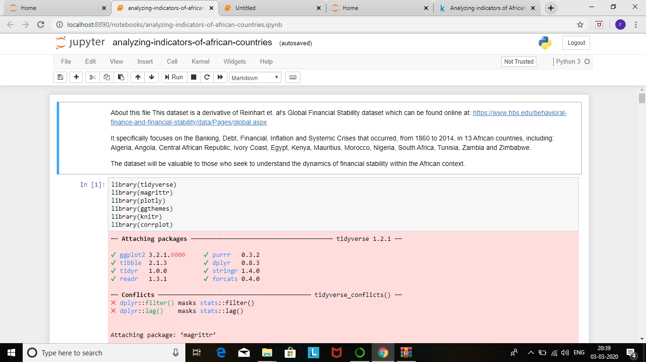

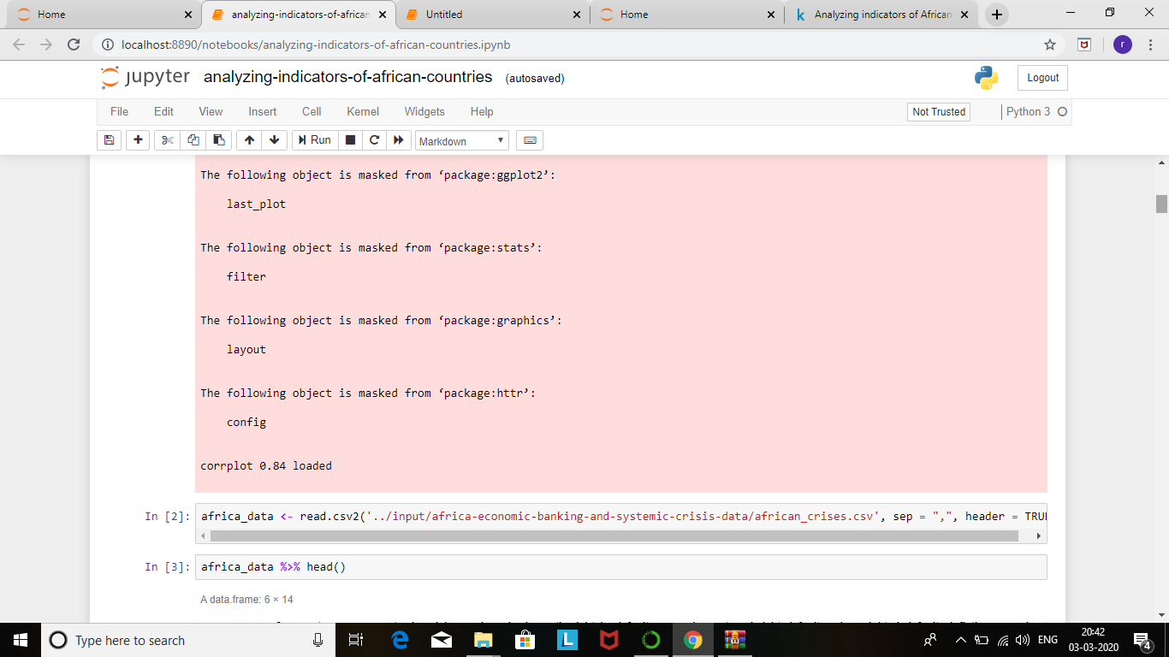

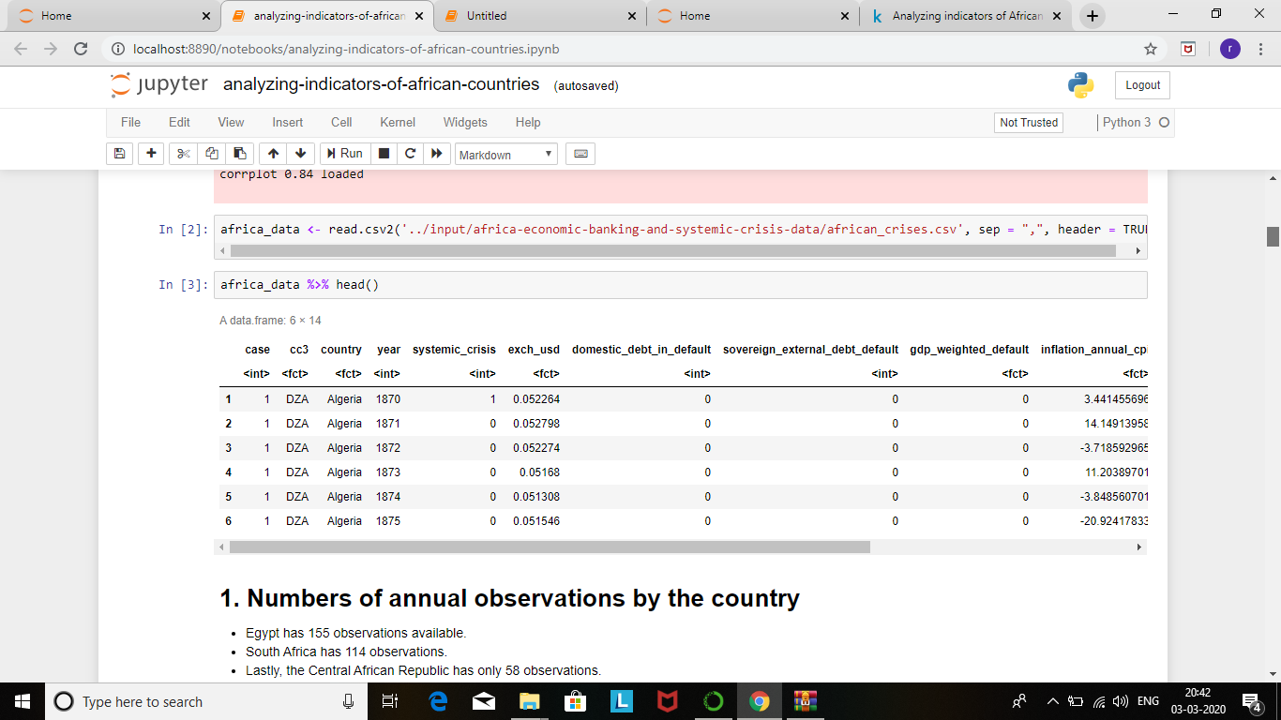

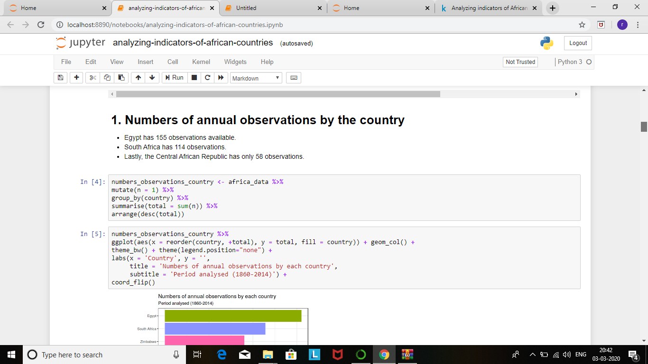

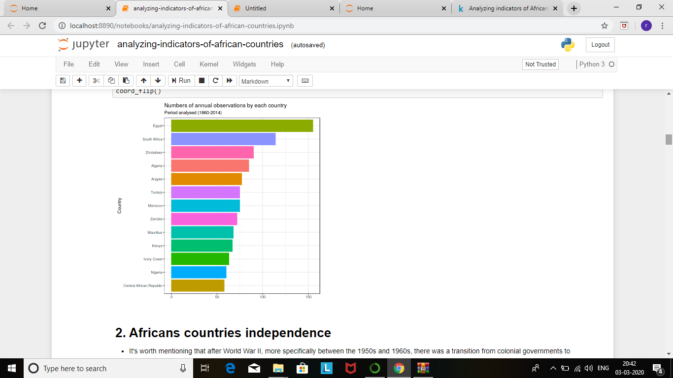

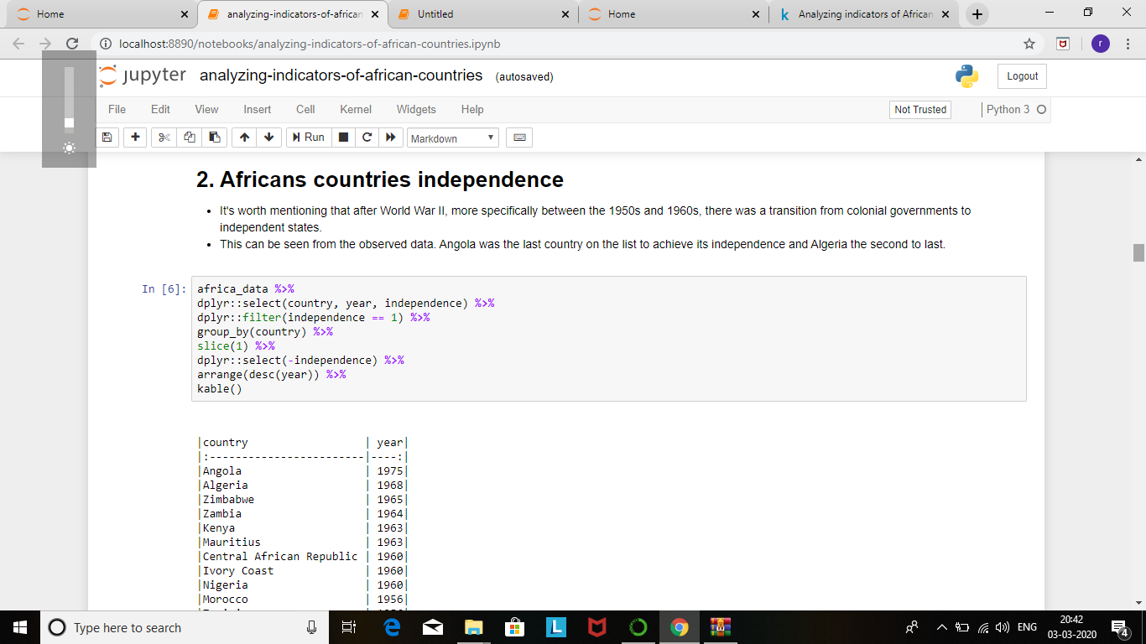

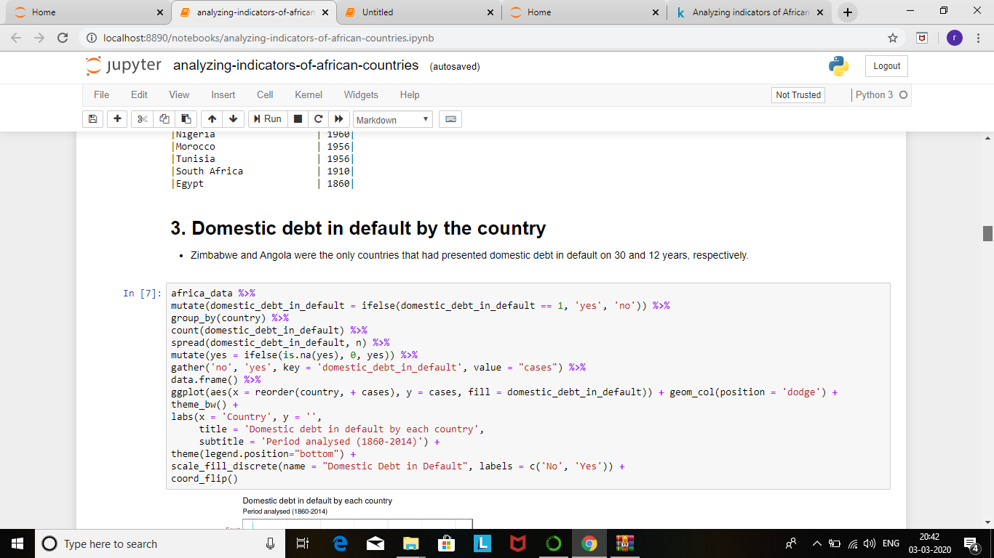

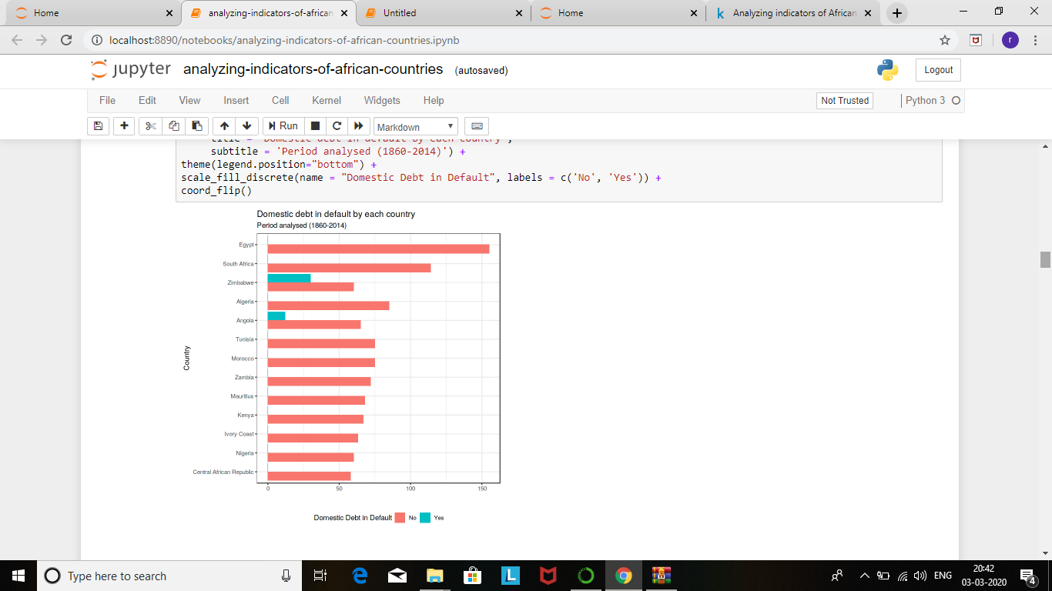

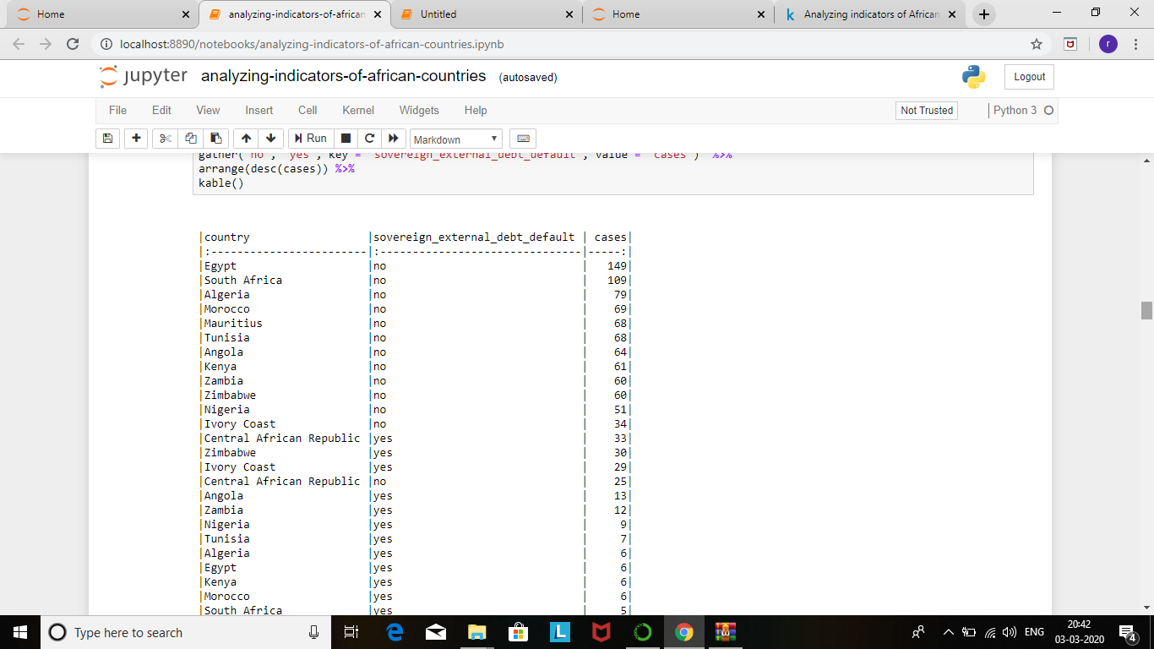

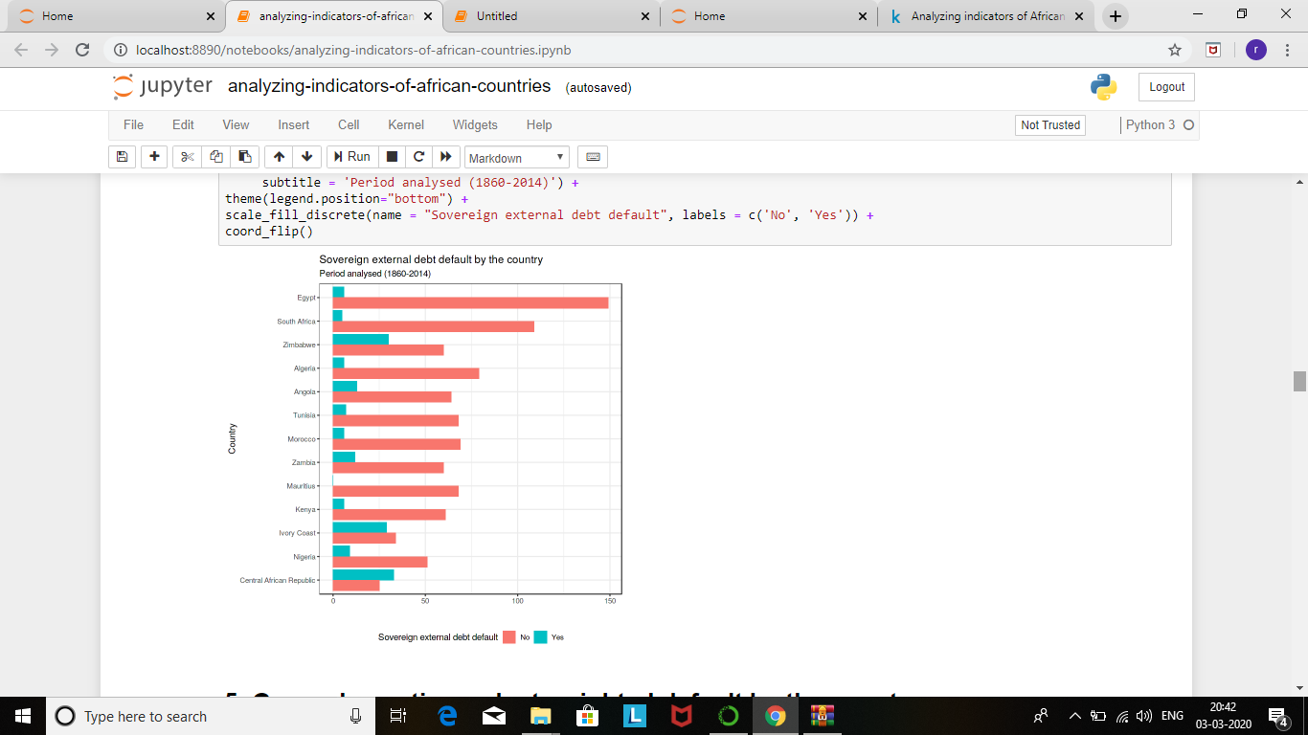

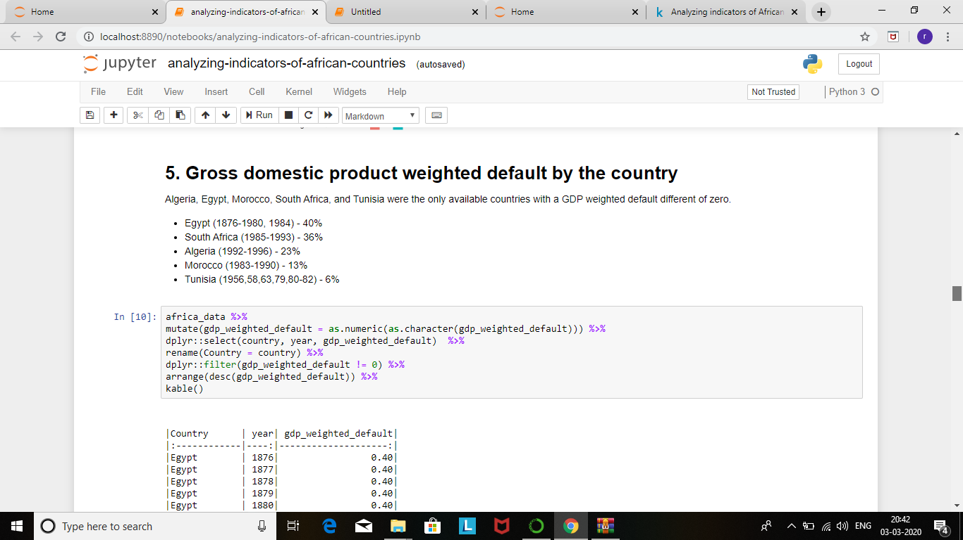

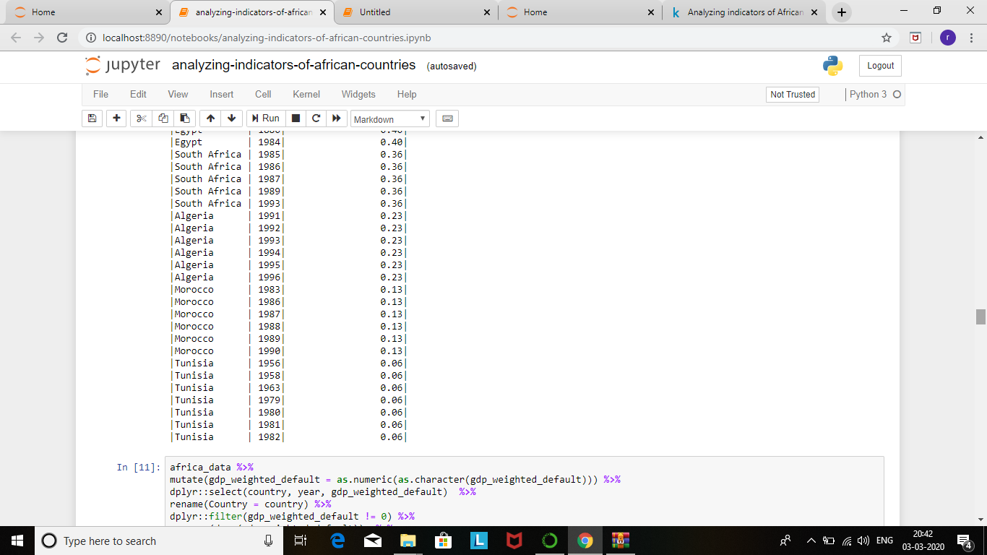

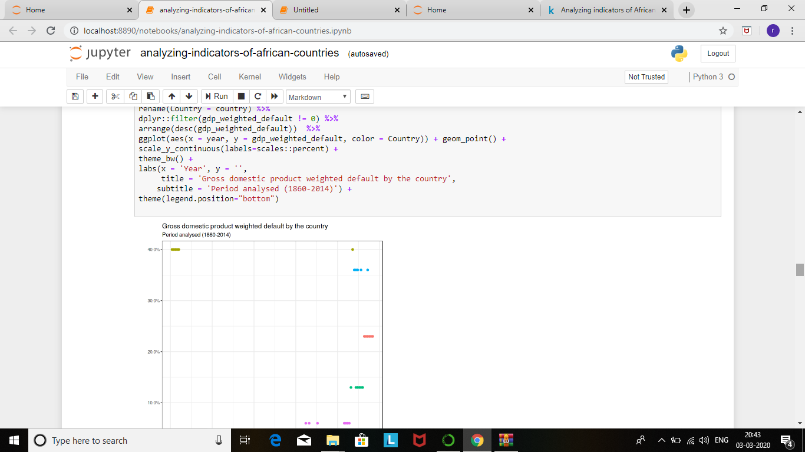

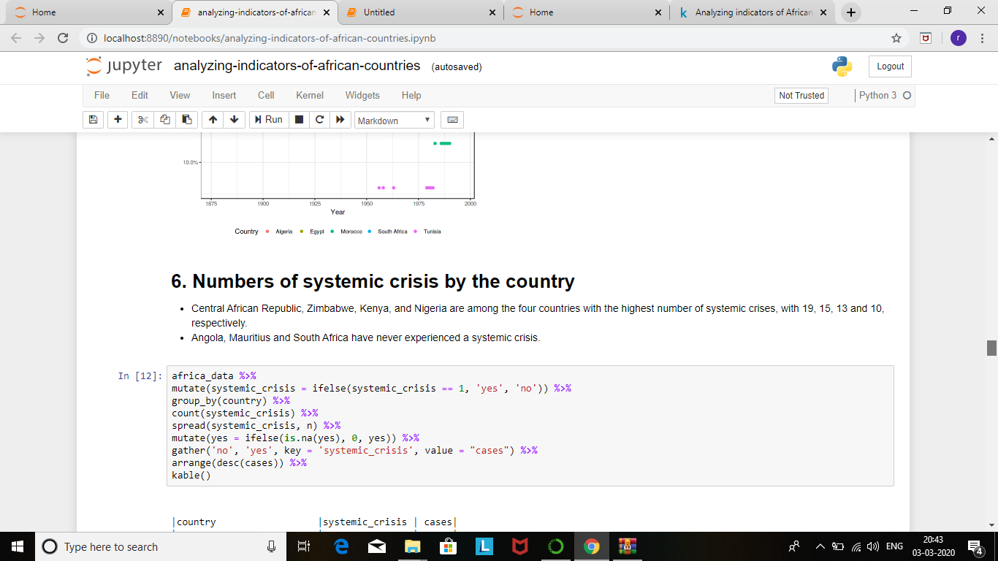

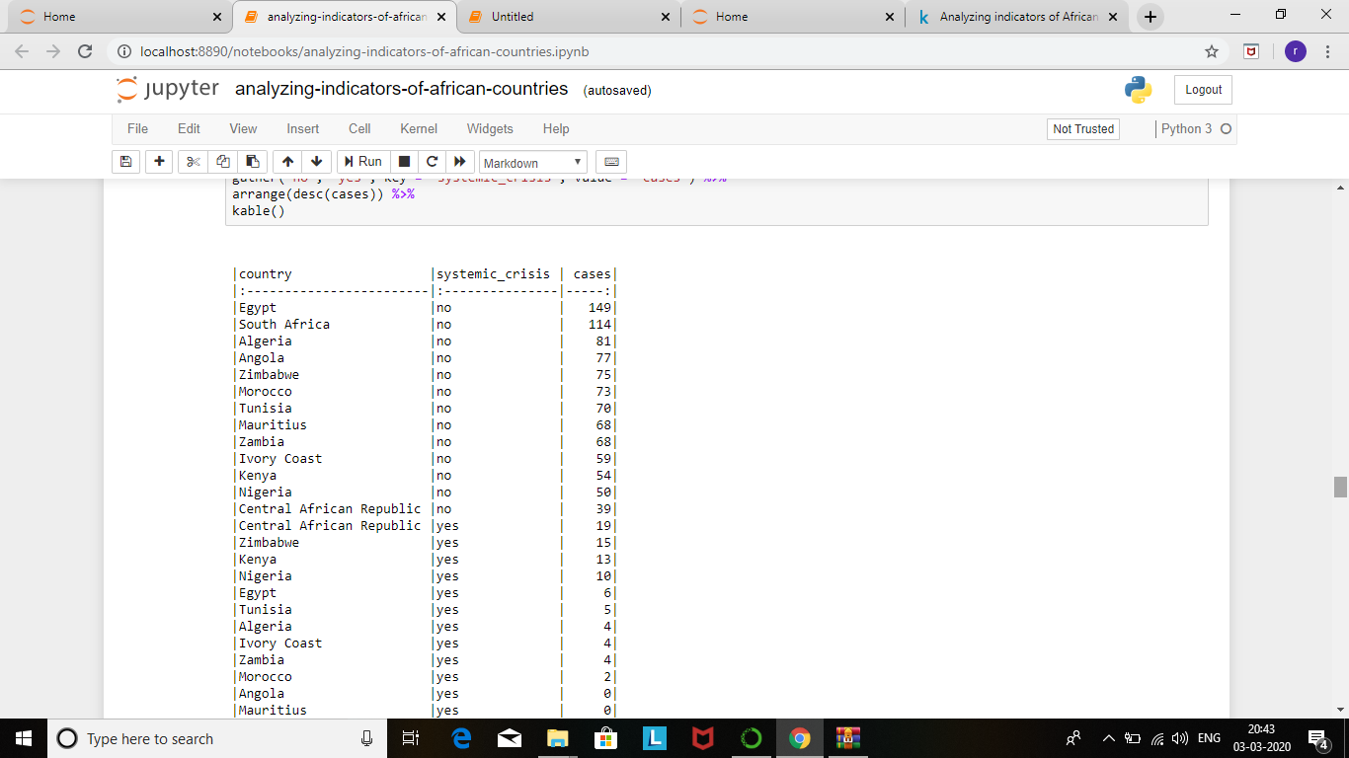

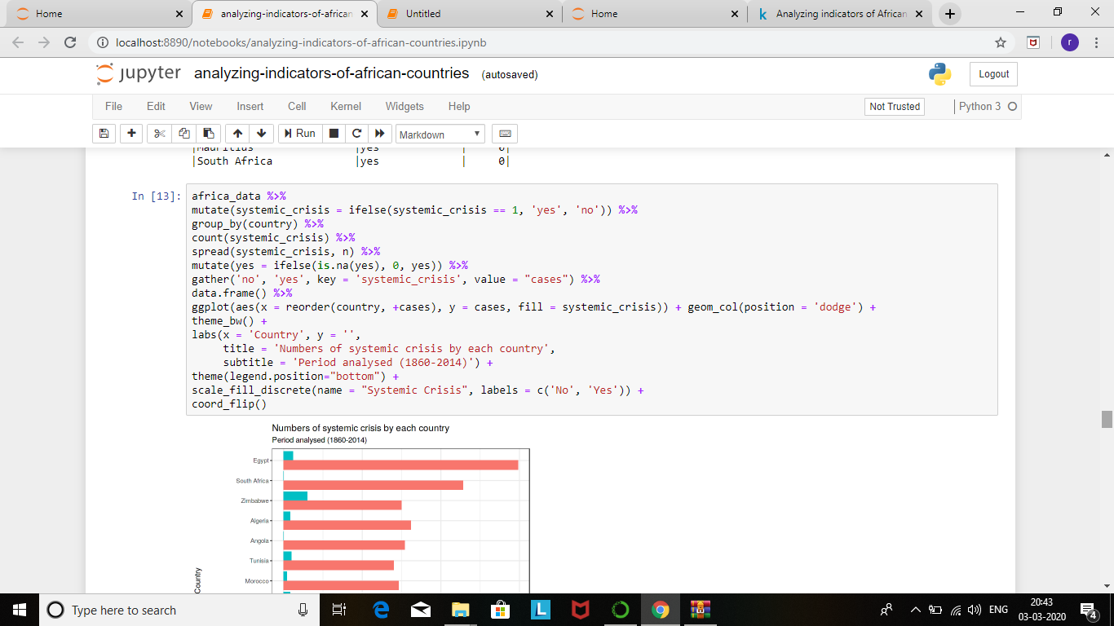

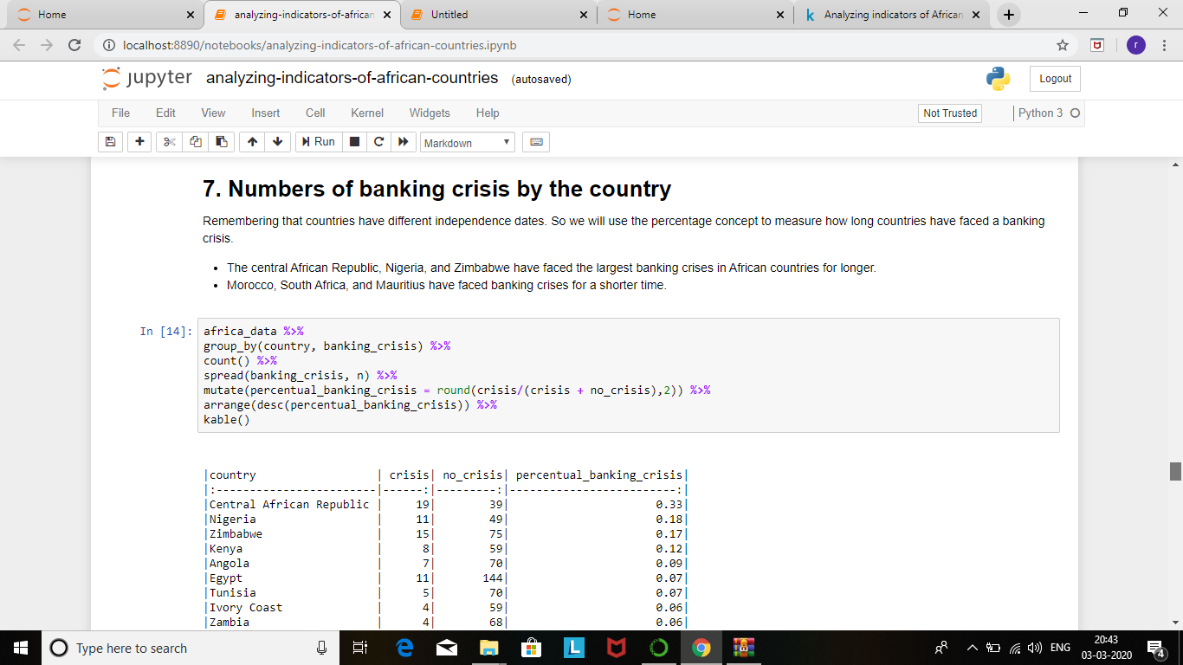

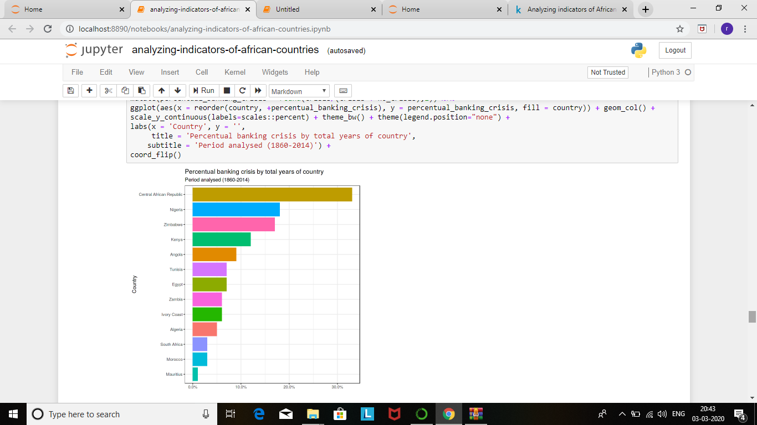

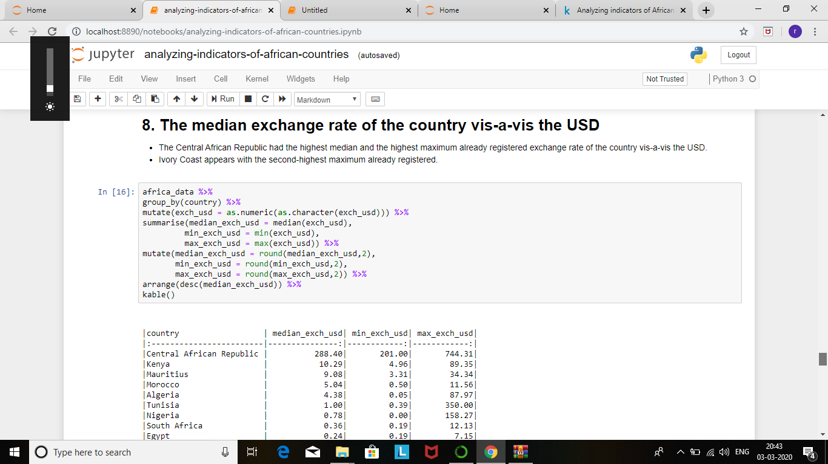

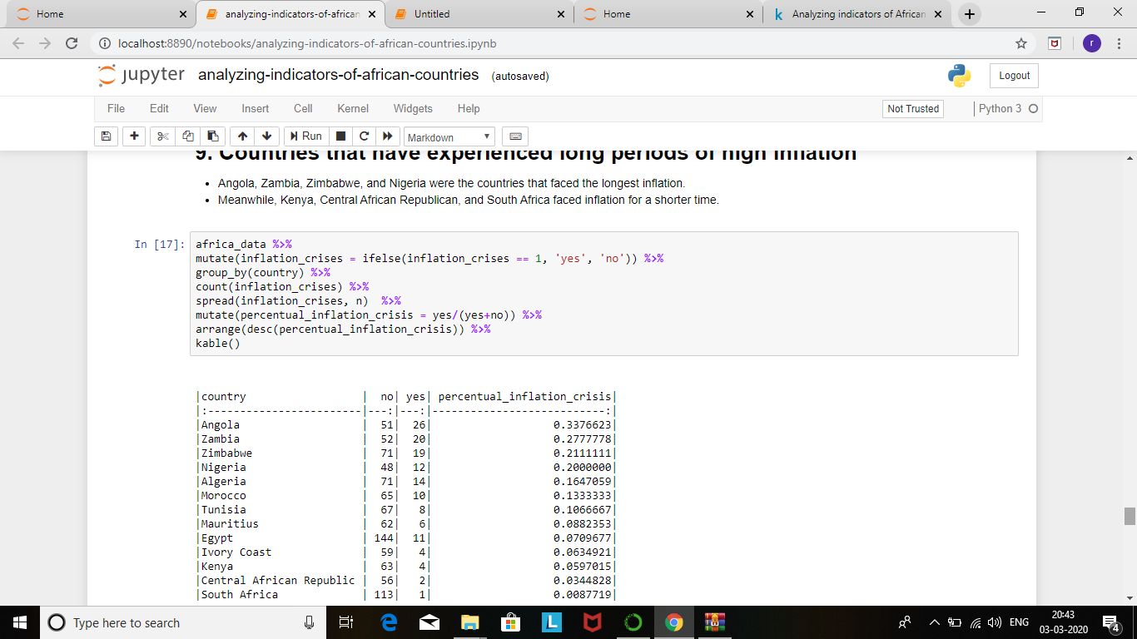

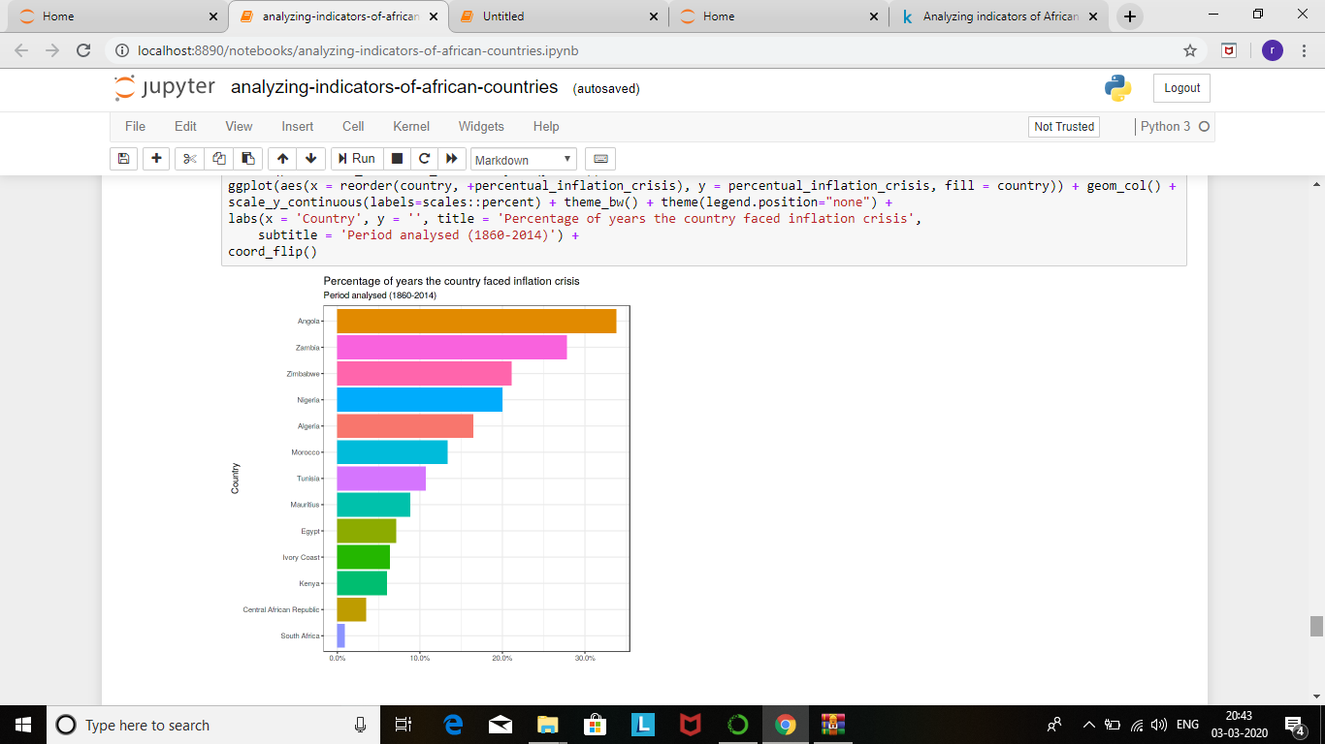

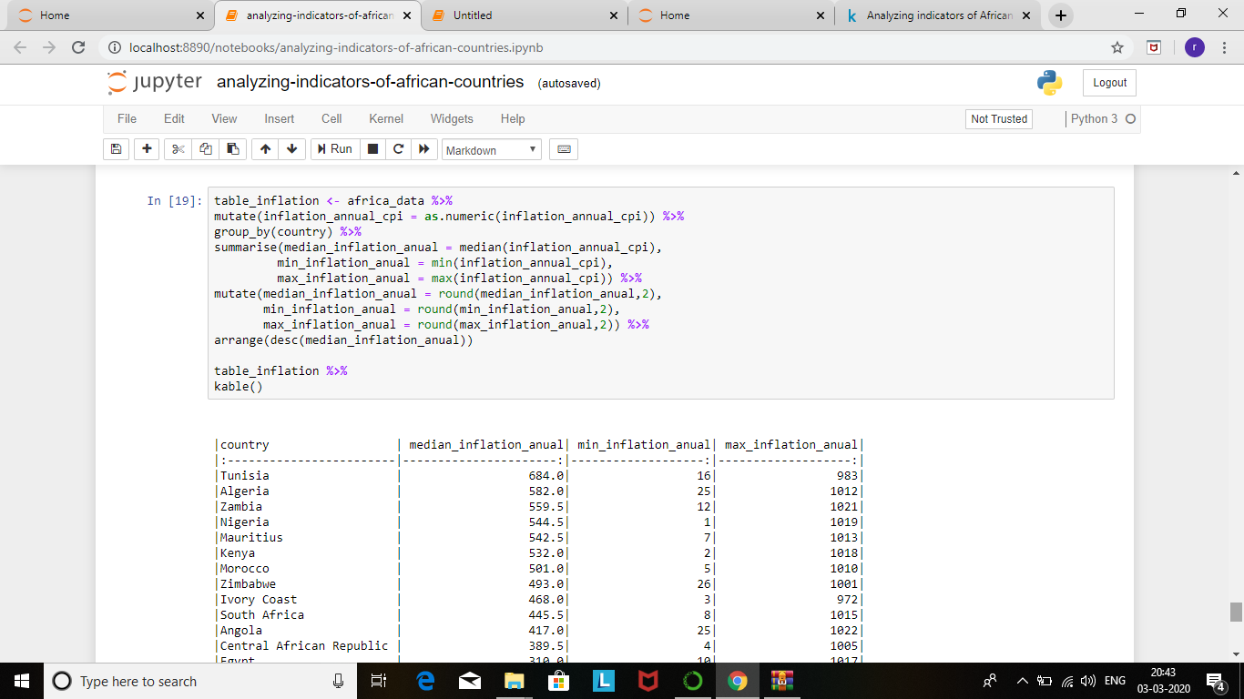

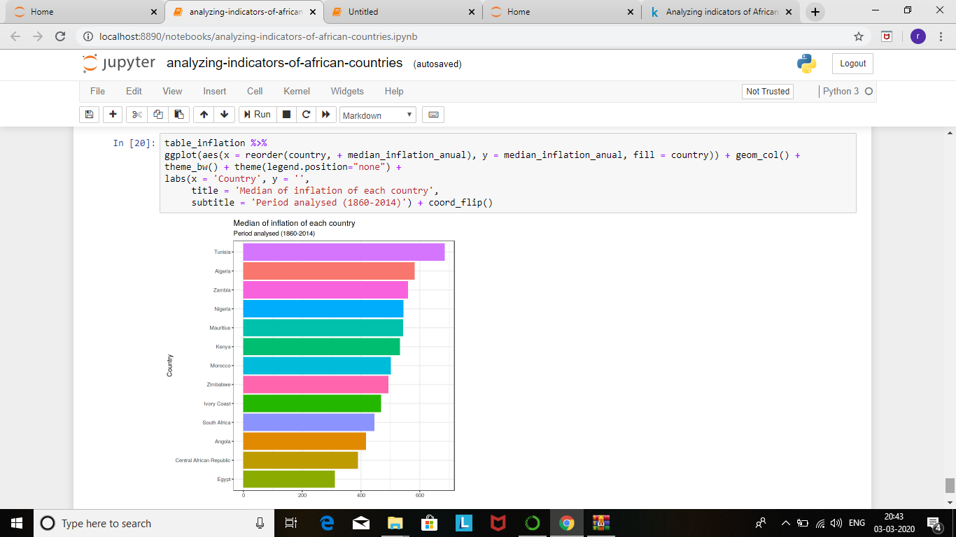

**CONCLUSION:**

The banking crises mainly resulted from poor governance and high exposure to commodity markets in a context of falling international prices. 6 Without Bissau Guinea. 7 The NPL ratio is the percentage of nonperforming loans to total loans during the years [t, t+5], where t is the starting year of the crisis. NPL tend to be high at the beginning of a banking crisis, averaging about 50 percent of loans and running as high as 90 percent of total loans. 8 OUTPUT LOSS is computed by extrapolating trend real GDP, based on the trend in real GDP growth up to the year preceding the crisis, and taking the sum of the differences between actual real GDP and trend real GDP expressed as a percentage of trend real GDP for the period [t, t+3], where t is the starting year of the crisis. 9 Liability side: attracting deposits; asset side: restoring adequate levels of bank credit.

**URL:**